Regular Expressions: Form Validation

Downloaded and started apache2

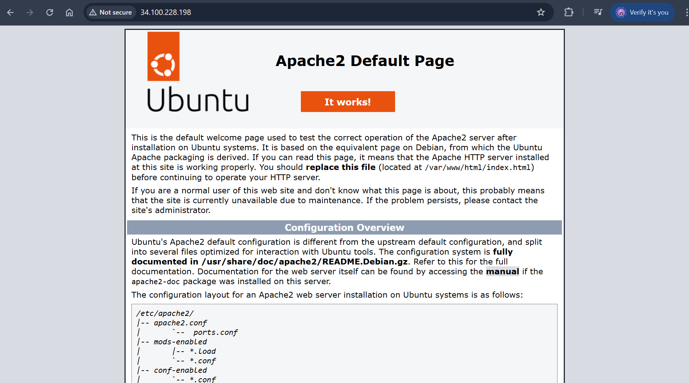

Apache is working!

Created all three files with content

Form in public IP

Password validation

